**Software Development 4**

**Revision Lab**

The project folder contains a set of packages that implements partial functionality for a banking application. Please familiarise yourself with each of the Java files. You are required to build the GUI using Java Swing components and to add event handling to the application using AWT.

A sample of the GUI is shown below

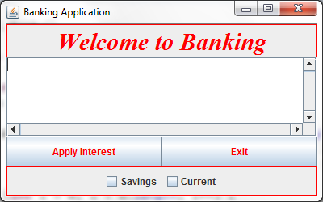

**Event Handling**

When the user interacts with the GUI you need to write the code to handle the events. You need to work out which method(s) in the model need to be called in order to handle the events

1. **Savings** Checkbox - When the user selects this checkbox, the account details for all savings accounts are displayed in the textarea

2. **Current** Checkbox - When the user selects this checkbox, the account details for all current accounts are displayed in the textarea

3. When both checkboxes are selected, all account details are displayed in the textarea

The following is a sample of the output generated when both checkboxes are selected.

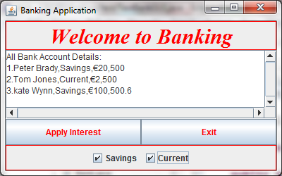

4. **Apply Interest** - When this button is pressed all account details are displayed with the updated balance which includes the interest. Again you need to call the relevant method(s) to apply this change.

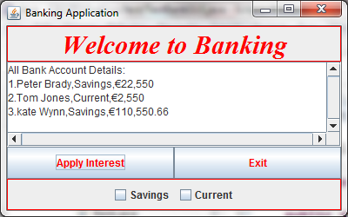

5**. Exit** - When this button is pressed the application ends